Reading Responses IM Casey, Margaret Hamilton

I really enjoyed watching Reas’ talk. I was fascinated by his explanation of the philosophy behind his work that draws from contemporary art, age-old ideas behind aesthetics, and an urge to explore the space between order and chaos, structure and randomness, leading to mesmerizing works.

One of the things I learned from his talk is that complexity can emerge from the simplest instructions. In the yes/no example, a single line of code produced a wonderful pattern that has unpredictable variations due to the introduction of randomness. Just to think that something so complex and visually beautiful can emerge from written instructions, a mere page of code, is really incredible.

Some of Casey’s works reminded me of the Japanese artist Yayoi Kusama. Specifically, she is known for using dots in her paintings, and I attached one example below. To me, her paintings are also about chance and structure. The structure is that all of the dots have the same shape and color (even though the circles are not perfect, as they are painted and not printed). What varies is the size of the dots and their positioning. The painting looks like it could have been made with a simple code. This raises the question how the meaning of art changes depending on its process of creation. Furthermore, with the code, millions more of similar images can be created within an instant, whereas with the physically painted one it takes a much higher opportunity cost to create more of these images.

* 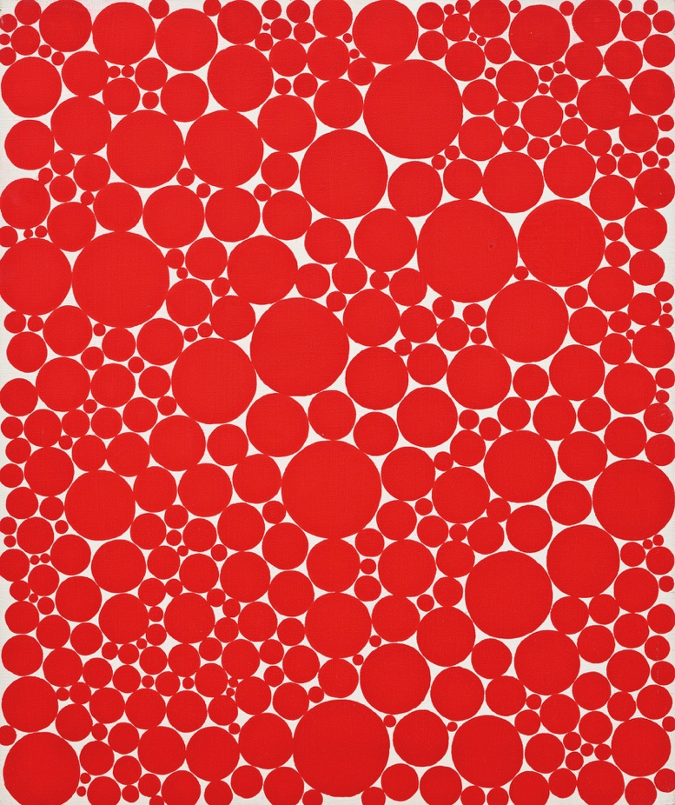

*Dot* by Yayoi Kusama, 1989

**Robert Mcmillan Her Code Got Humans on the Moon—And Invented Software Itself**

Even though a lot has changed in the tech field since Margaret Hamilton was working for Nasa, the gender imbalance is still strongly prevalent. She must have been incredibly courageous to work in a male dominated field as a working mother in a time when women were even less recognized as scientists and researchers than now. I used to be very set on studying physics, and I experienced a lot of pressure from my family and friends to pursue something else instead, as it was “too hard” of a subject for a girl to study. I often found myself in situations where I was the only female student when I participated in physics programs, and often felt like I didn’t belong there because of my gender. Therefore, I find Margaret’s story both inspiring and encouraging.